Writing Task 1

Rules: 150 - 225 Words 20 minutes

Write 8-10 Sentences TOTAL

You are writing a report (essay)

3 Goals

1. Explain the Graph in your own words. Tell me what the whole thing is about.
2. Tell me the general – common points on the graph. What are the highs and the lows on the graph. What are the greatest and least (less). How many steps are in the process.
3. Give me two Paragraphs of Specific Comparisons/Details. In the 3rd and 4th paragraphs is where we compare the numbers/percentages(%)

Majority: (1-4)

1. Line graph
2. Table
3. Pie Chart
4. Bar Chart/graph

**Rarely**

1. Process
2. Diagram
3. Line Graph

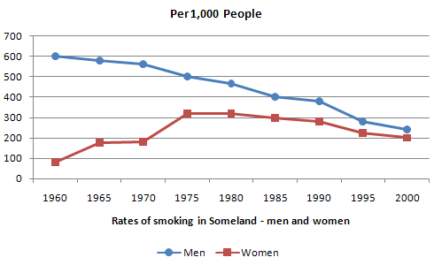

1. Bar Chart/graph

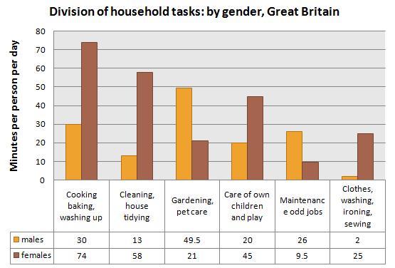

1. Table

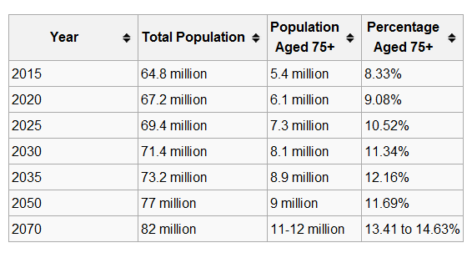

1. Pie Charts

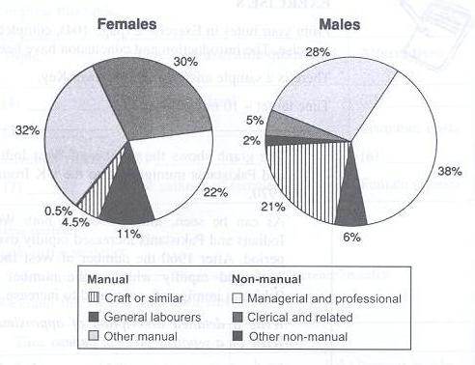

1. Process

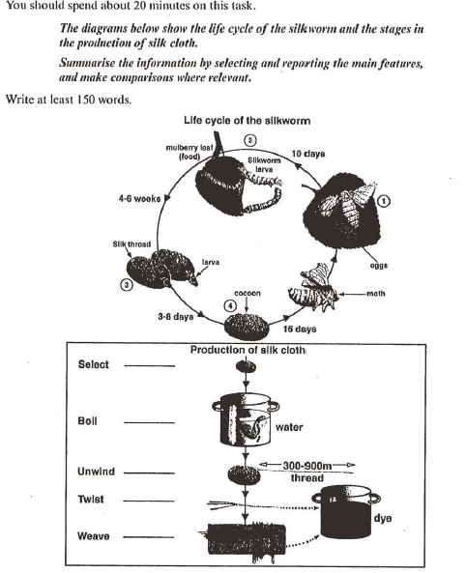

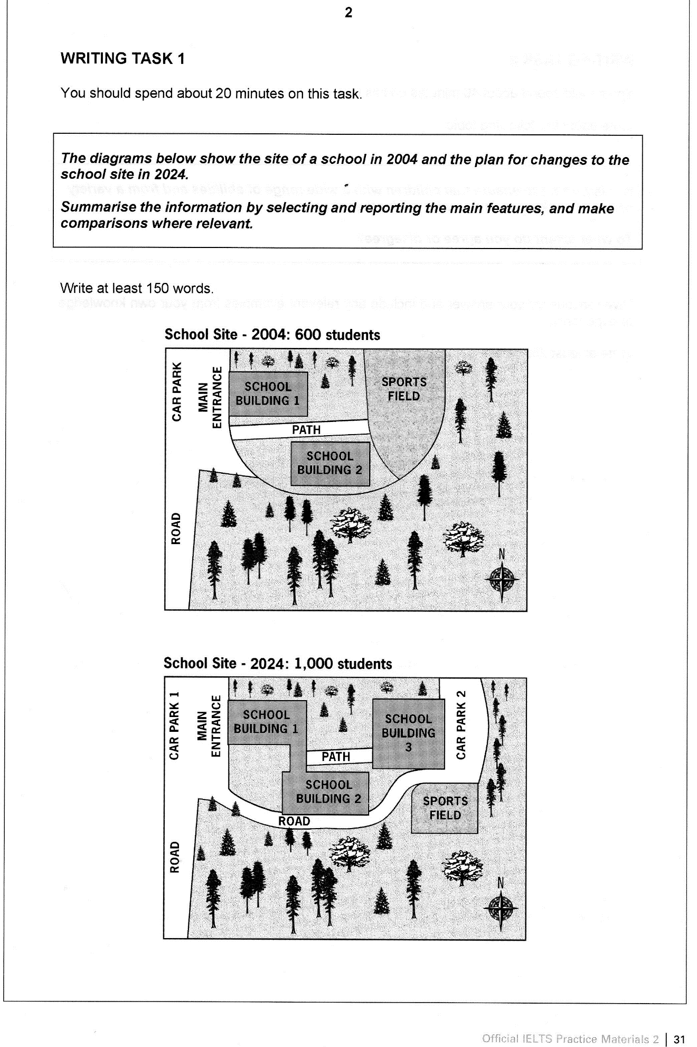

[**IELTS Writing Task 1: full essay**](http://ielts-simon.com/ielts-help-and-english-pr/2013/05/ielts-writing-task-1-full-essay.html)

***The graph below shows the average number of UK commuters travelling each day by car, bus or train between 1970 and 2030.***

[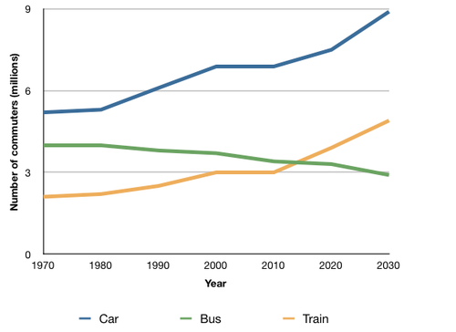](http://ielts-simon.com/.a/6a0120a5bb05d8970c019101f28f36970c-pi)

***[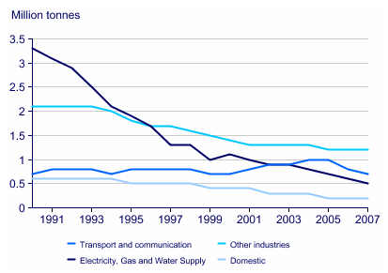](http://ielts-simon.com/.a/6a0120a5bb05d8970c0120a8cfa023970b-pi)***

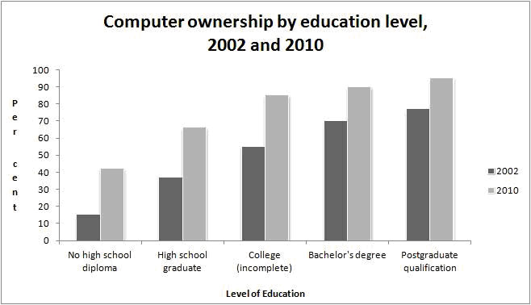

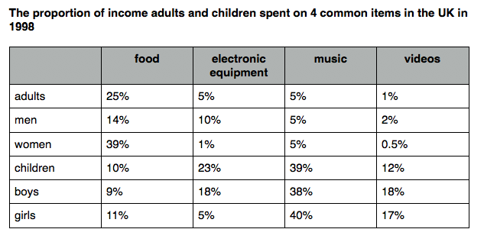

Paragraph 4 (children, boys, girls) or (music and videos)

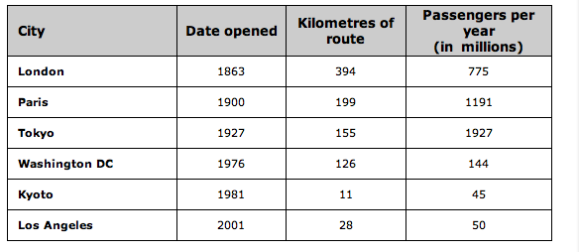

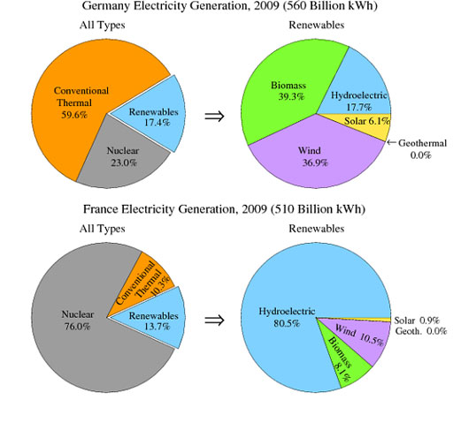

***The table below shows the proportion of different categories of families living in poverty in Australia in 1999.***

[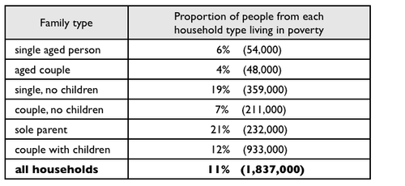](http://ielts-simon.com/.a/6a0120a5bb05d8970c015390cbb20e970b-pi)

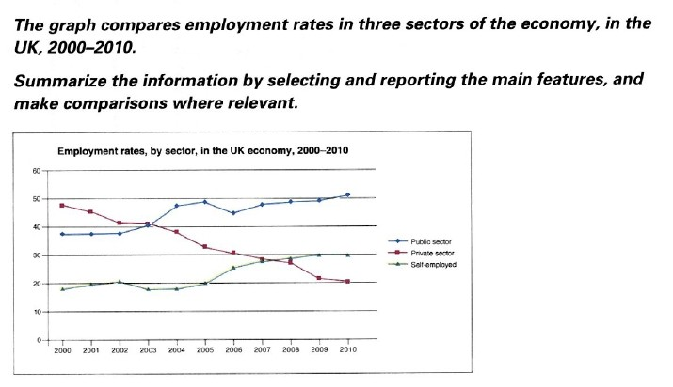

**The charts below show household spending patterns in two countries between 1980 and 2008.**

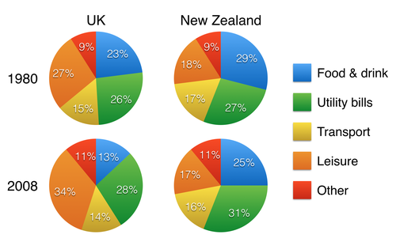

***The table below gives information on consumer spending on different items in five different countries in 2002.***

Percentage of national consumer expenditure by category - 2002

[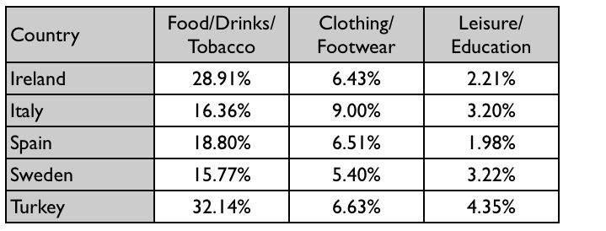](http://ielts-simon.com/.a/6a0120a5bb05d8970c0148c78b1eaf970c-pi)

**The graphs show changes in spending habits of people in UK between 1971 and 2001.**

**Write a report to a university lecturer describing the data.**

Write at least 150 words

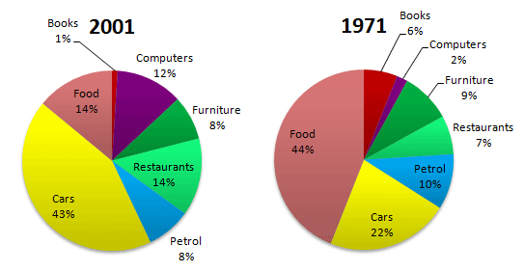

**The chart below shows global sales of the top five mobile phone brands between 2009 and 2013.**...

[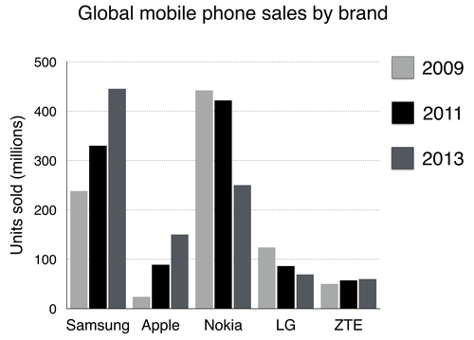](http://ielts-simon.com/.a/6a0120a5bb05d8970c01b8d0cae291970c-pi)

***The table below gives information about the underground railway systems in six cities.***

[](http://ielts-simon.com/.a/6a0120a5bb05d8970c0147e2f6c162970b-pi)

|  |
| --- |
| **The table illustrates the proportion of monthly household income five European countries spend on food and drink, housing, clothing and entertainment.** |

**Proportion of household income five European countries spend on food and drink, housing, clothing and entertainment.**

|  |  |  |  |  |
| --- | --- | --- | --- | --- |
|  | **Food and drink** | **Housing** | **Clothing** | **Entertainment** |
| **France** | 25% | 31% | 7% | 13% |
| **Germany** | 22% | 33% | 15% | 19% |
| **UK** | 27% | 37% | 11% | 11% |
| **Turkey** | 36% | 20% | 12% | 10% |
| **Spain** | 31% | 18% | 8% | 15% |

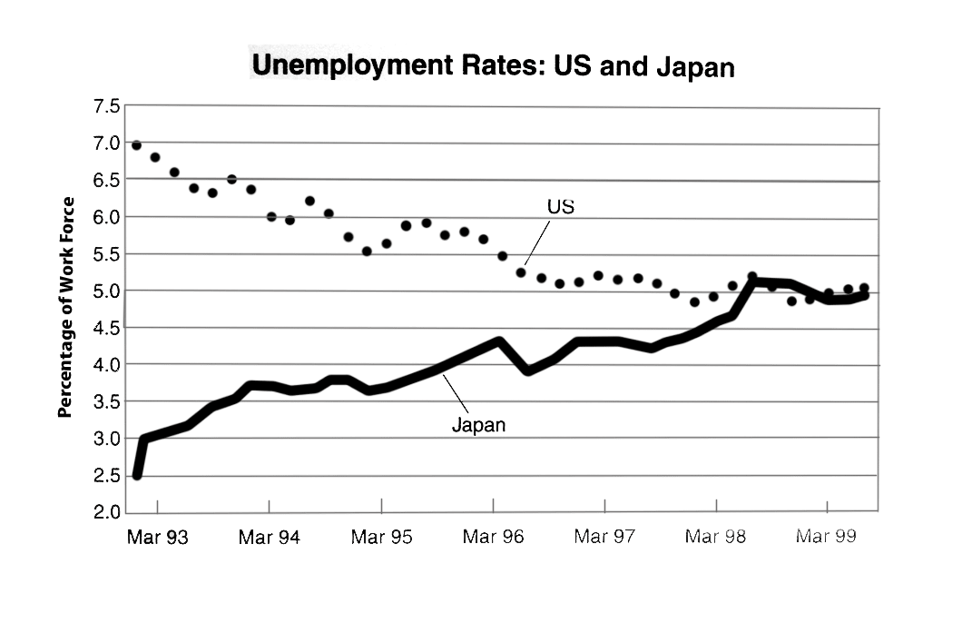

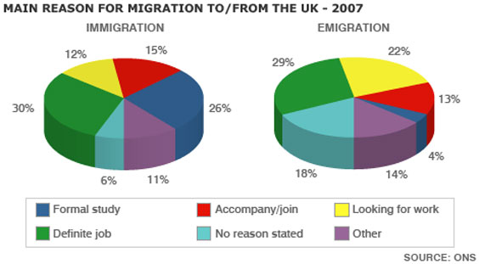

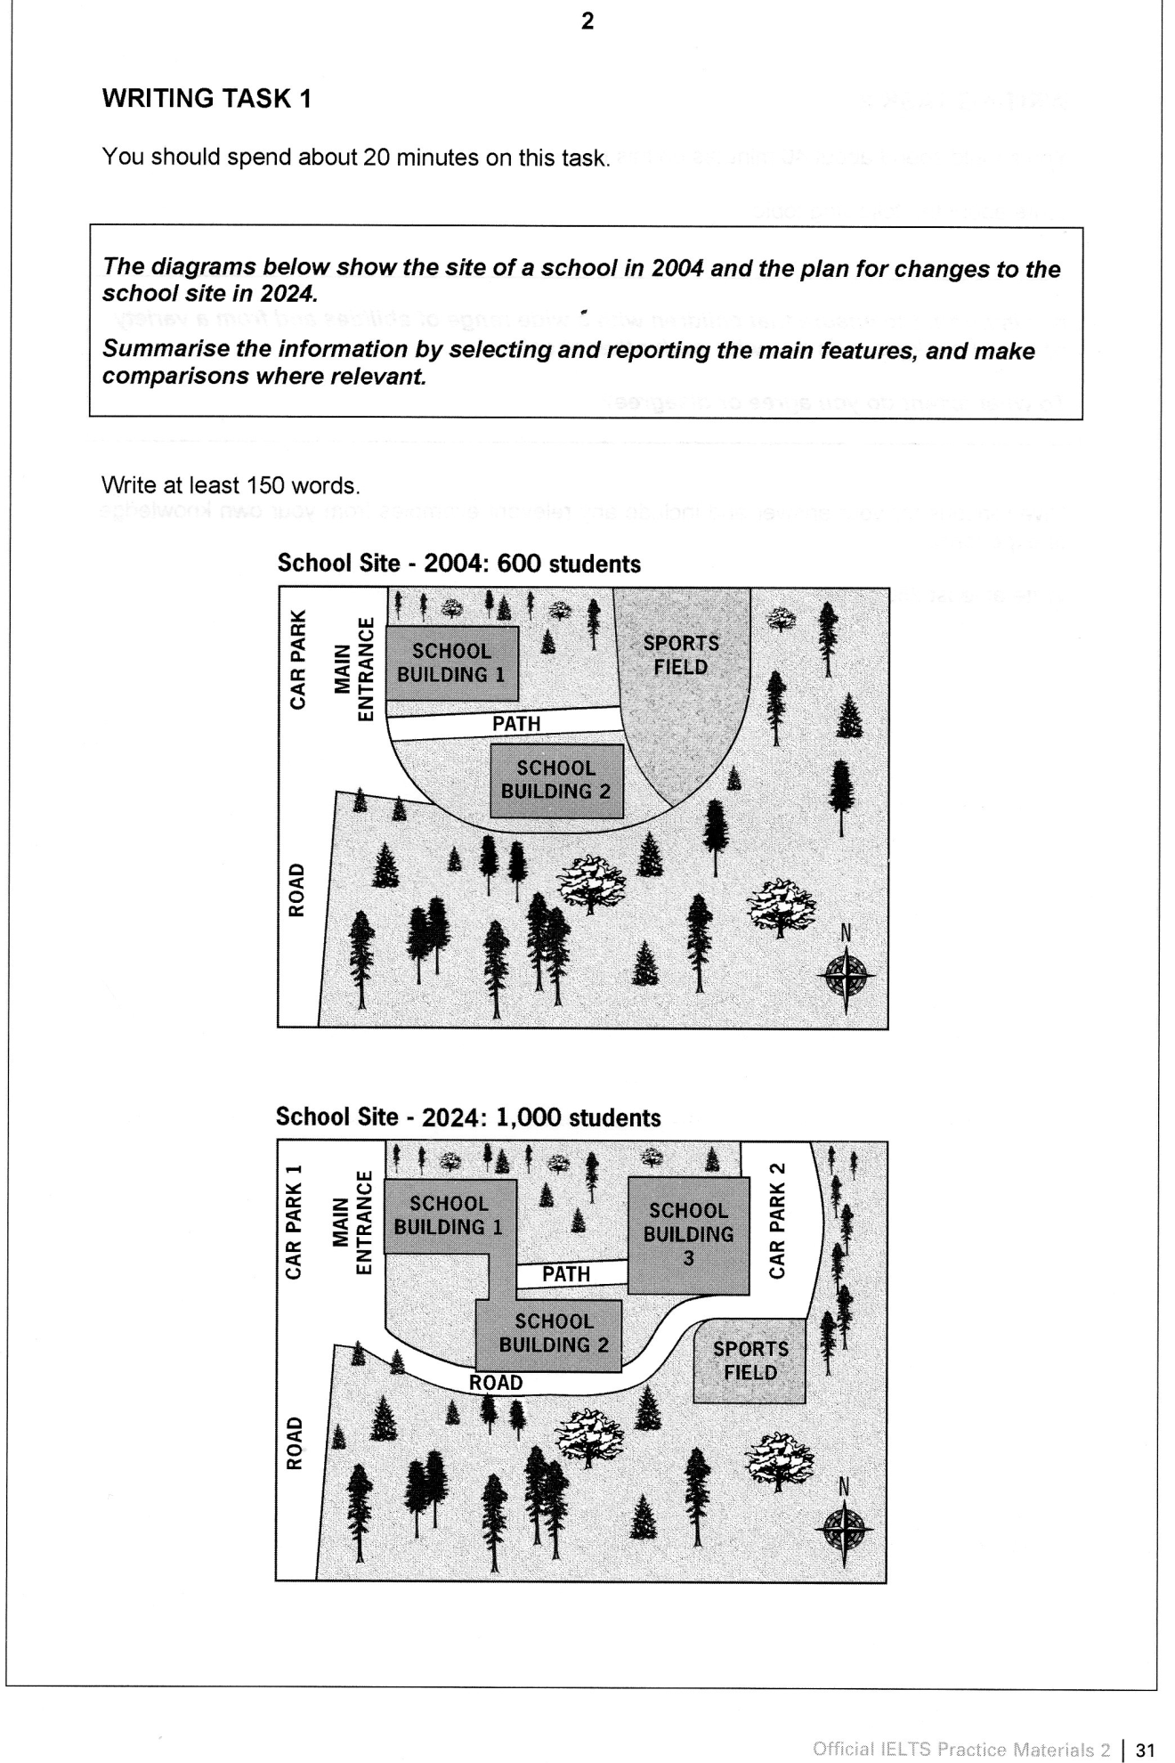

***The bar chart below shows the numbers of men and women attending various evening courses at an adult education centre in the year 2009. The pie chart gives information about the ages of these course participants.***

[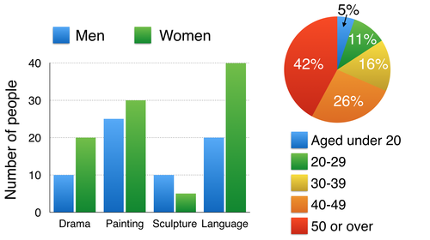](http://ielts-simon.com/.a/6a0120a5bb05d8970c01b8d0de0a43970c-pi)

[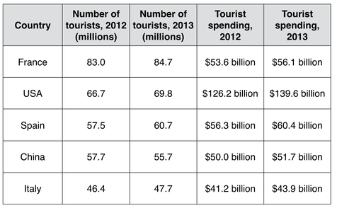](http://ielts-simon.com/.a/6a0120a5bb05d8970c01b7c74b2fbb970b-pi)

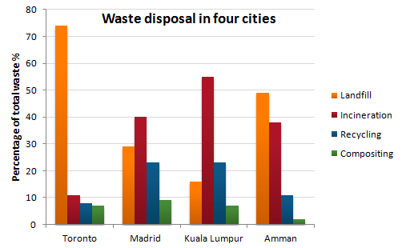

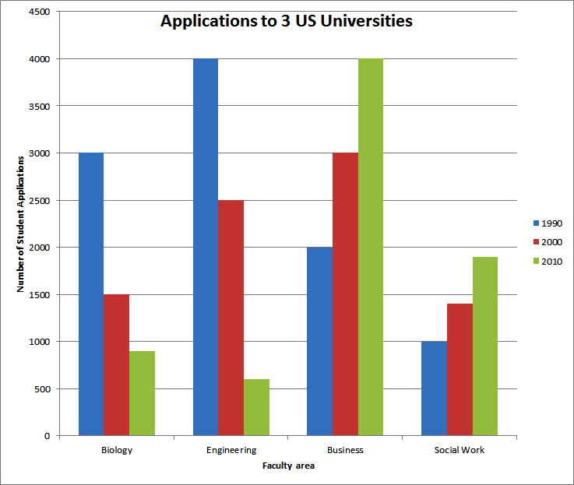

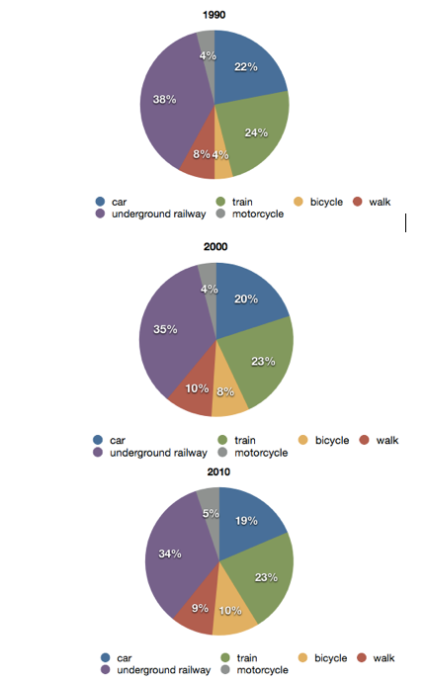

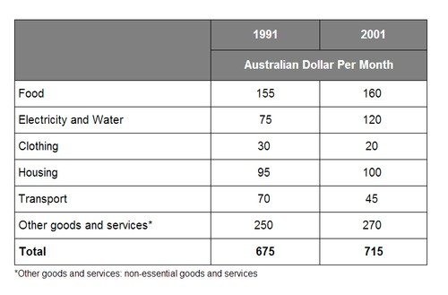

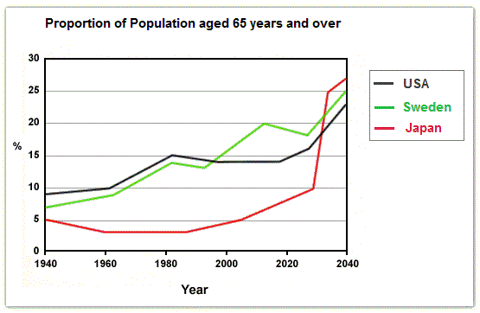

[**IELTS Writing Task 1: full essay**](http://ielts-simon.com/ielts-help-and-english-pr/2013/05/ielts-writing-task-1-full-essay.html)

***The graph below shows the average number of UK commuters travelling each day by car, bus or train between 1970 and 2030.***

[](http://ielts-simon.com/.a/6a0120a5bb05d8970c019101f28f36970c-pi)

You should spend about 20 minutes on this task.

**The graphs show changes in spending habits of people in UK between 1971 and 2001.**

**Write a report to a university lecturer describing the data.**

Write at least 150 words



Write at least 150 words



***The table below gives information on consumer spending on different items in five different countries in 2002.***

Percentage of national consumer expenditure by category - 2002

[](http://ielts-simon.com/.a/6a0120a5bb05d8970c0148c78b1eaf970c-pi)

**Write a report for a university lecturer describing the information in the graph below.**

Write at least 150 words.



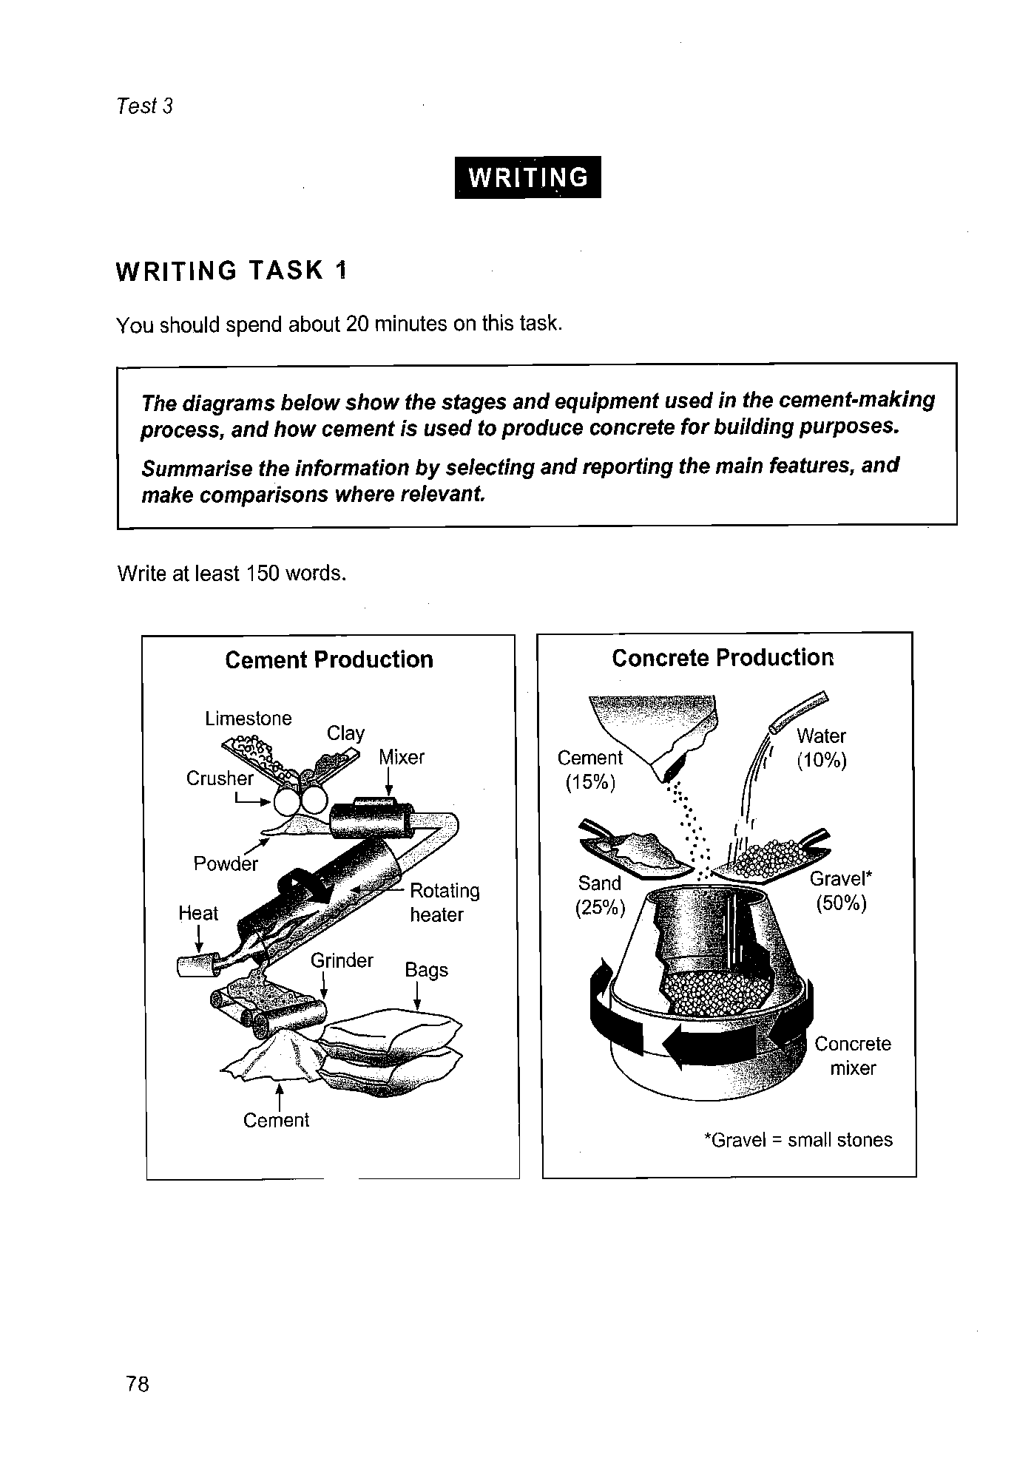

***The chart below shows the process of waste paper recycling.***

[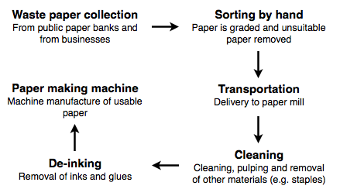](http://ielts-simon.com/.a/6a0120a5bb05d8970c019b00183230970d-pi)

|  |
| --- |
| You should spend about 20 minutes on this task.  **The table illustrates the proportion of monthly household income five European countries spend on food and drink, housing, clothing and entertainment.** *Summarize the information by selecting and reporting the main features and make comparisons where relevant.*  Write at least 150 words. |

**Proportion of household income five European countries spend on food and drink, housing, clothing and entertainment.**

|  |  |  |  |  |
| --- | --- | --- | --- | --- |
|  | **Food and drink** | **Housing** | **Clothing** | **Entertainment** |
| **France** | 25% | 31% | 7% | 13% |
| **Germany** | 22% | 33% | 15% | 19% |
| **UK** | 27% | 37% | 11% | 11% |
| **Turkey** | 36% | 20% | 12% | 10% |
| **Spain** | 31% | 18% | 8% | 15% |

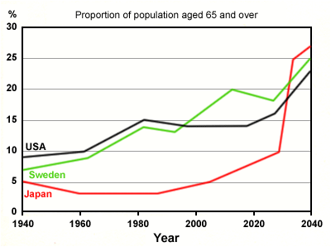

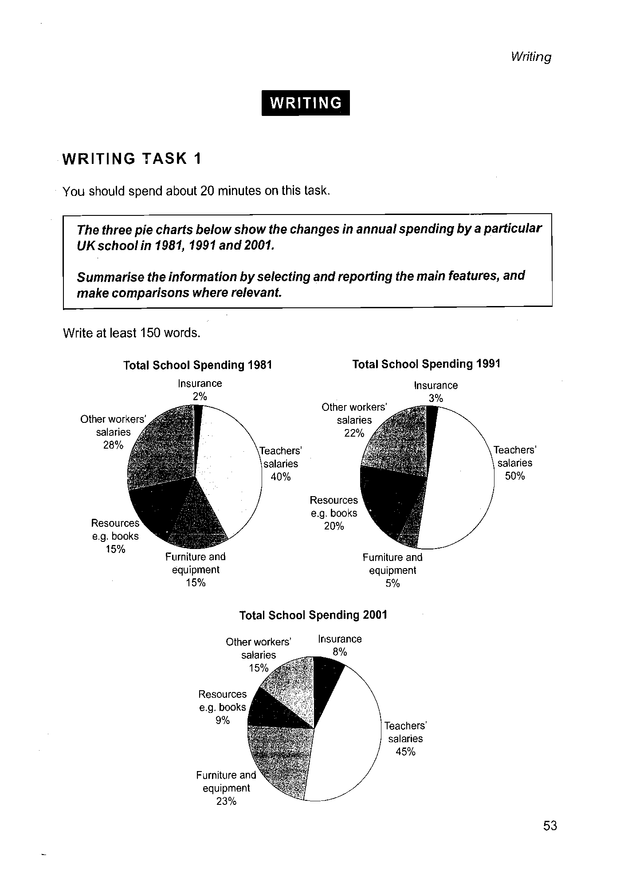

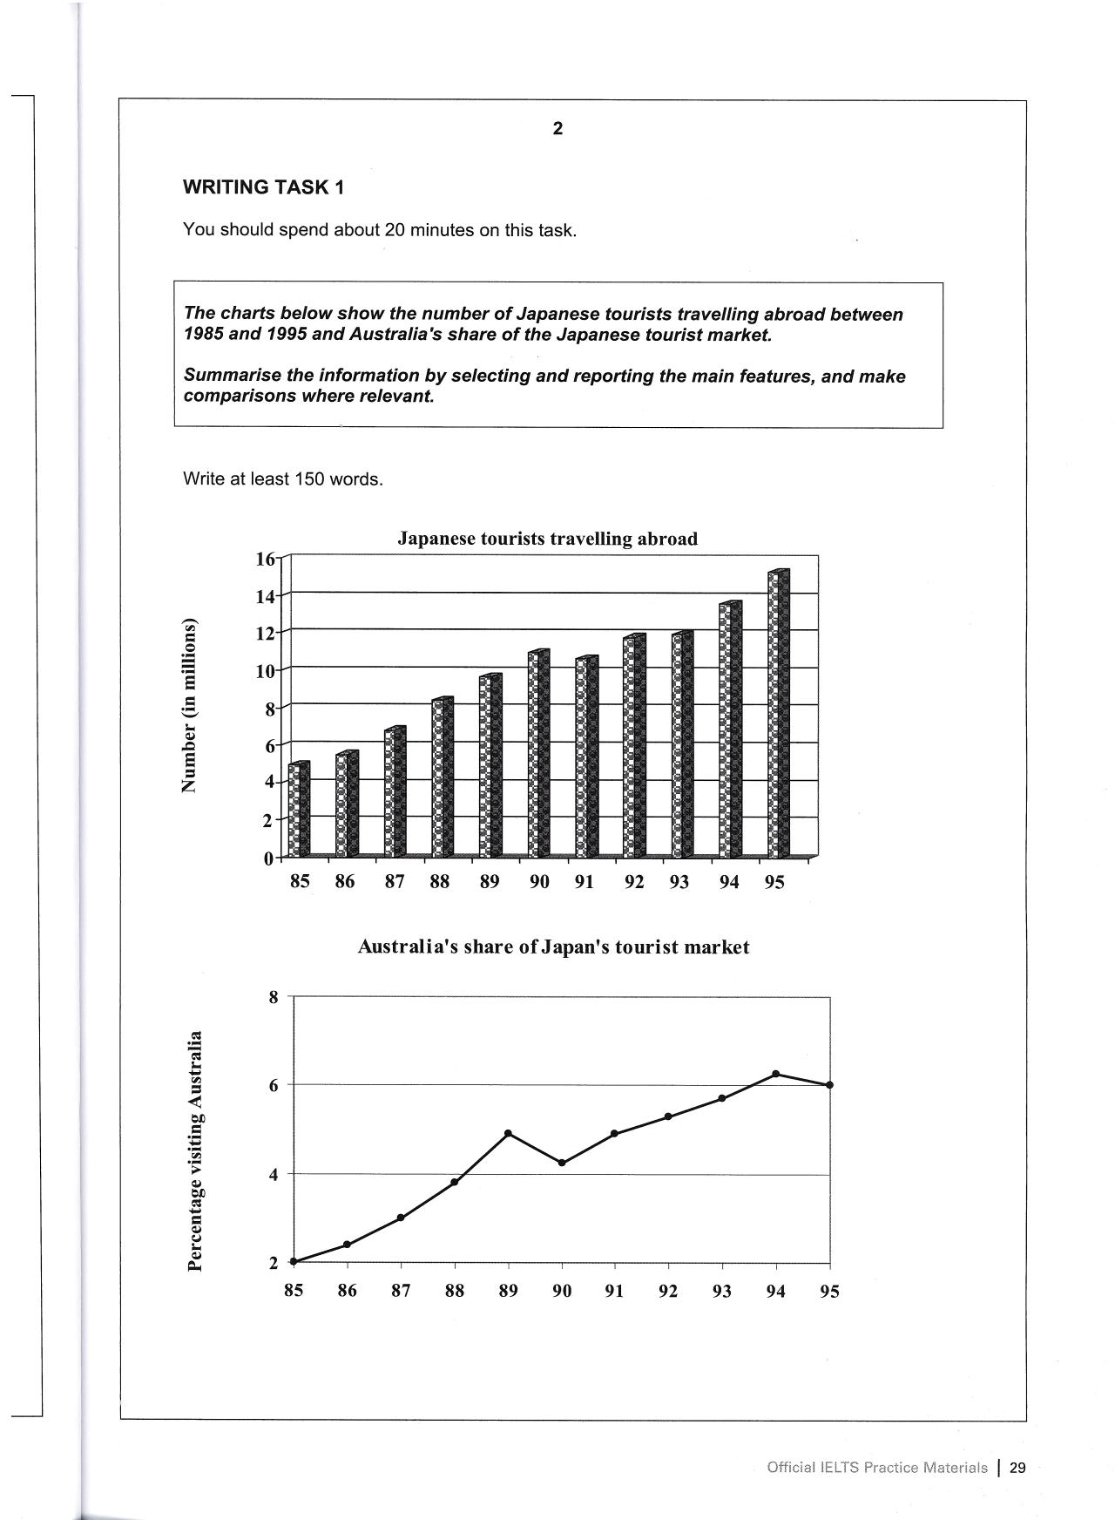

Bar Chart Example







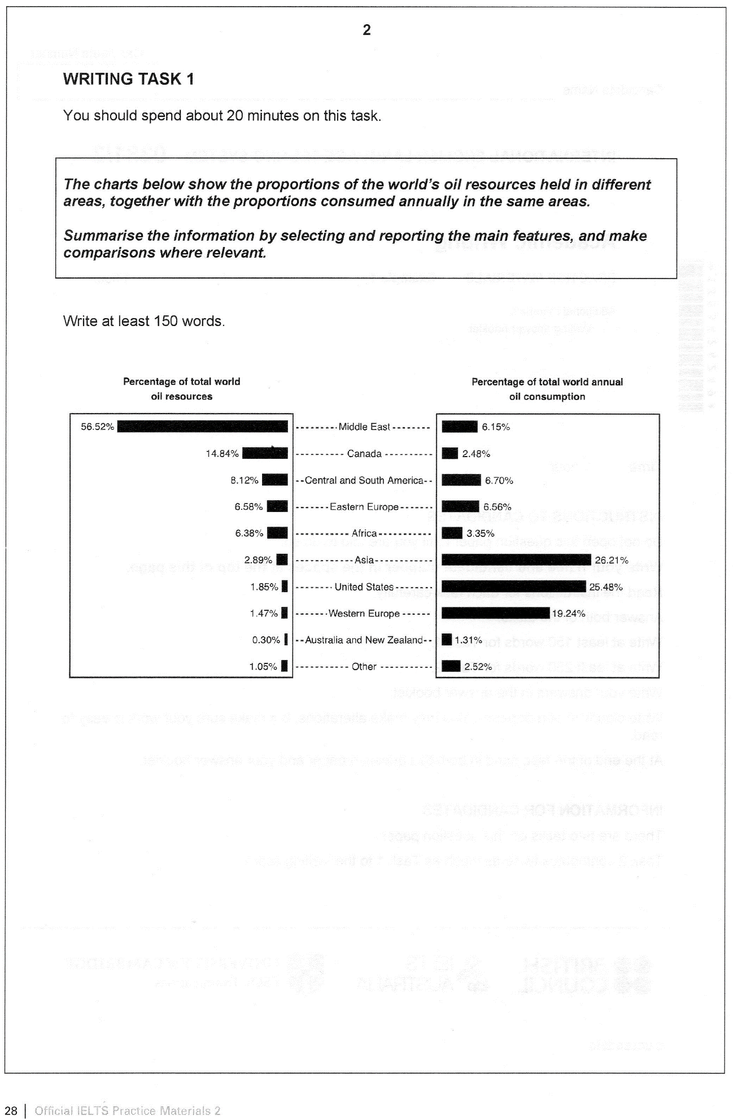

[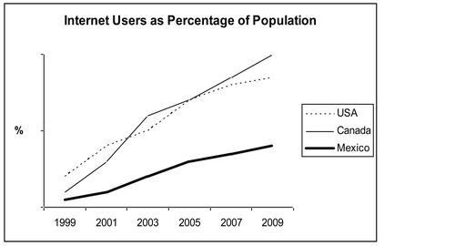](http://ielts-simon.com/.a/6a0120a5bb05d8970c0133f3433b15970b-pi)

You should spend about 20 minutes on this task.

**The graph below compares the changes in the birth rates of China and the USA between 1920 and 2000.**

**Summarise the information by selecting and reporting the main features and make comparisons where relevant.**

Write at least 150 words.

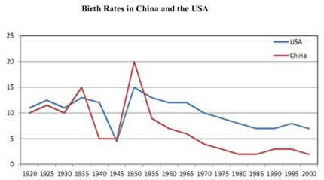



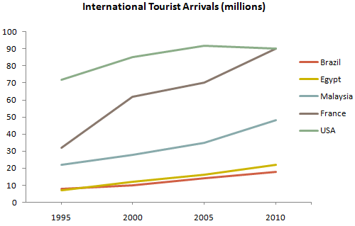

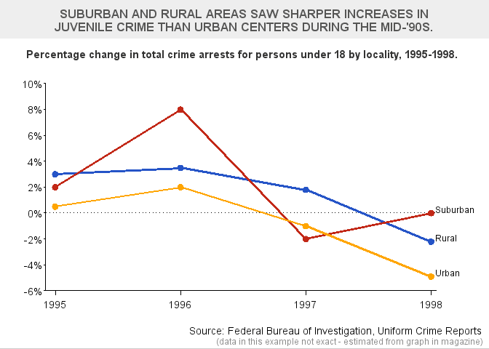

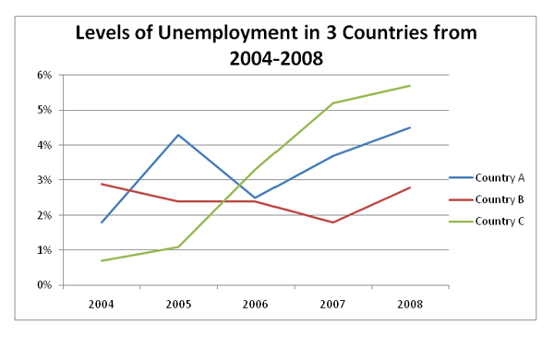



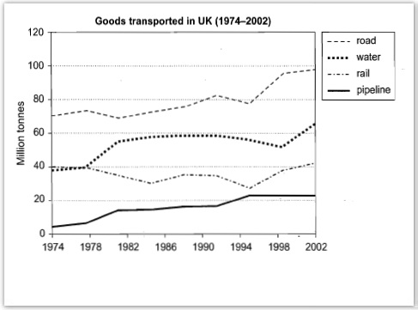

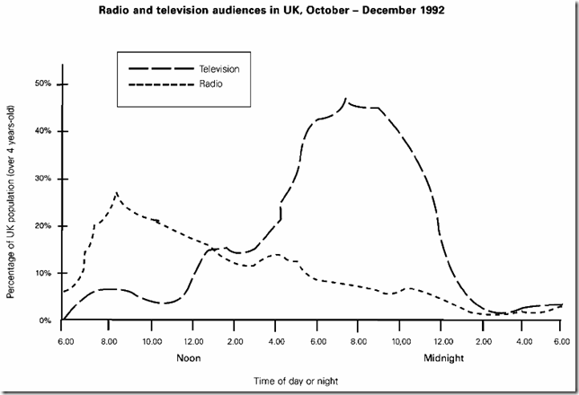

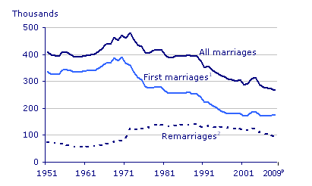

**IELTS Writing Task 1: look carefully!**

It's really important that you take time to notice and select the main features for your description of a graph, chart or diagram.

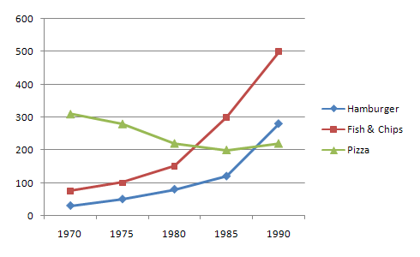

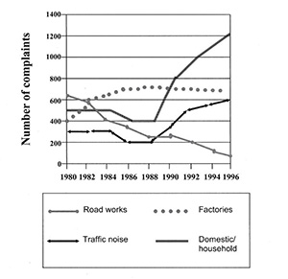

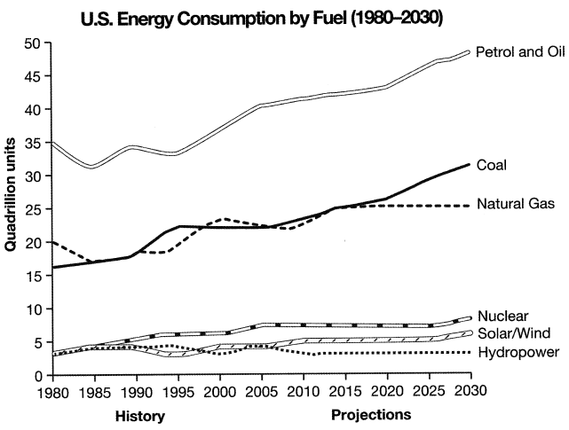

**The charts below show household spending patterns in two countries between 1980 and 2008.**



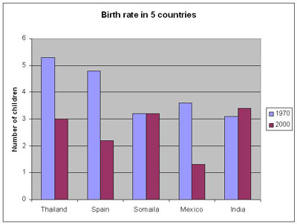



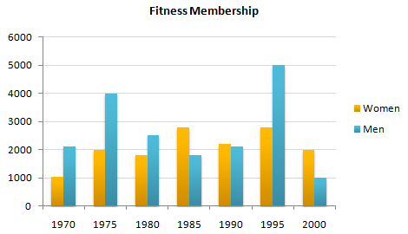

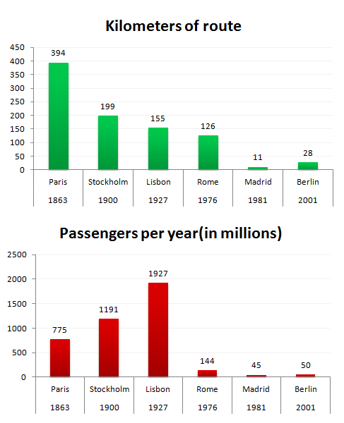



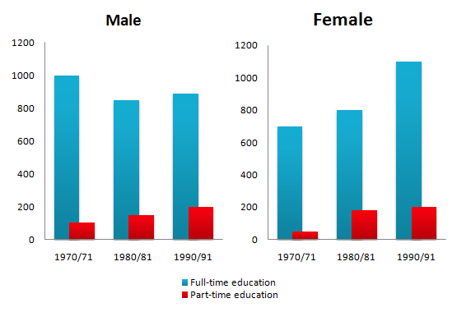

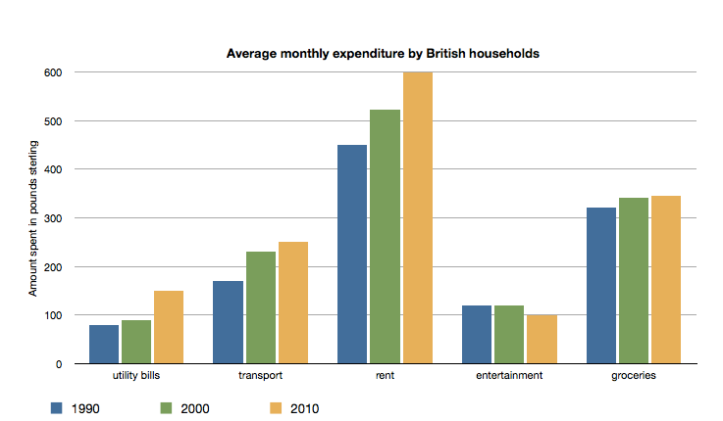

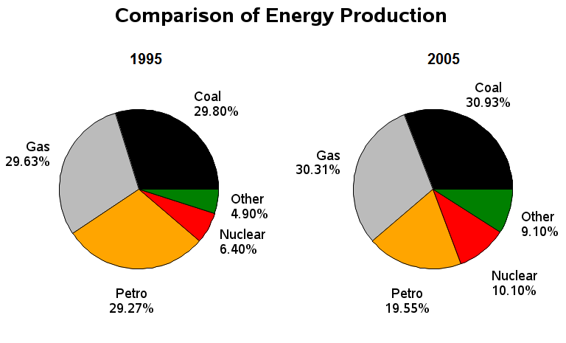

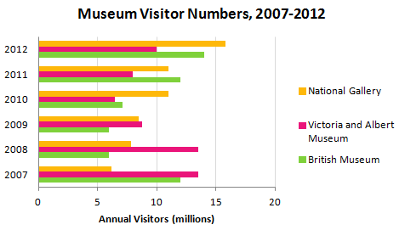

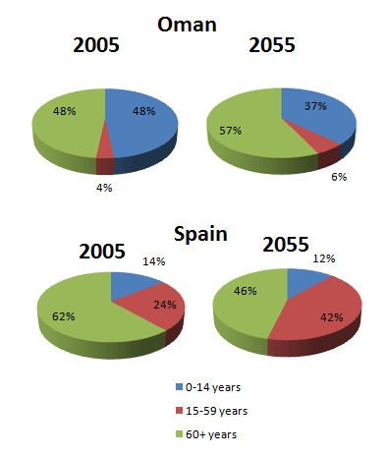

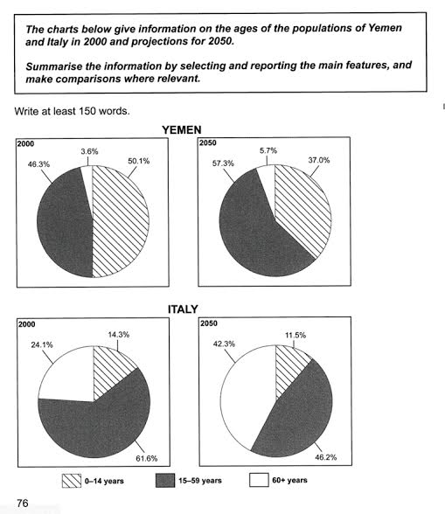

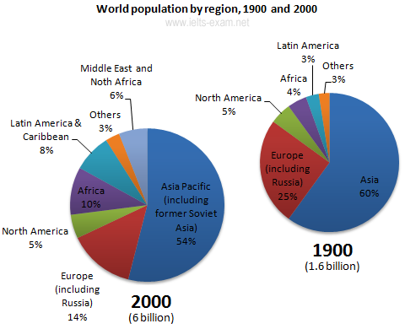

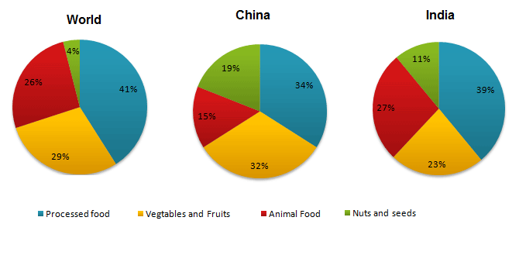

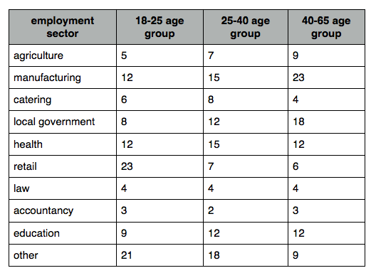

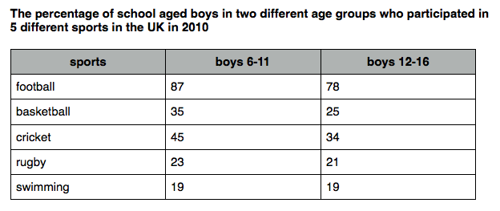

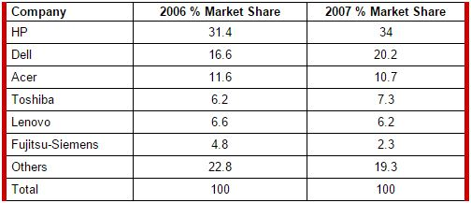



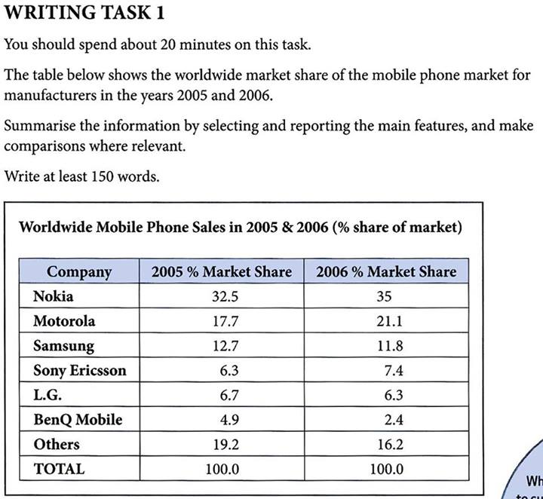

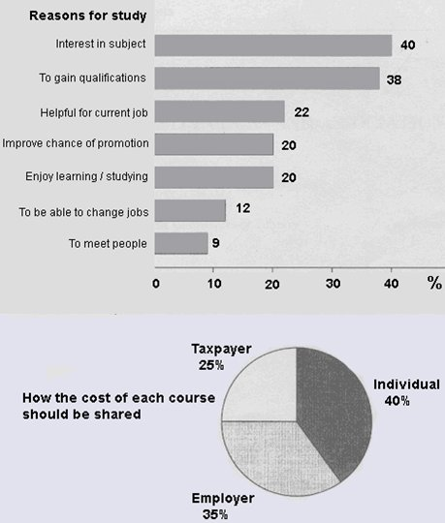

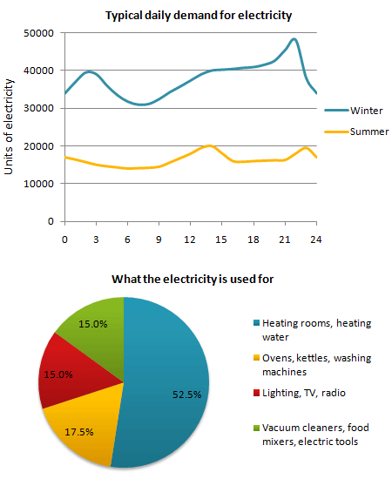

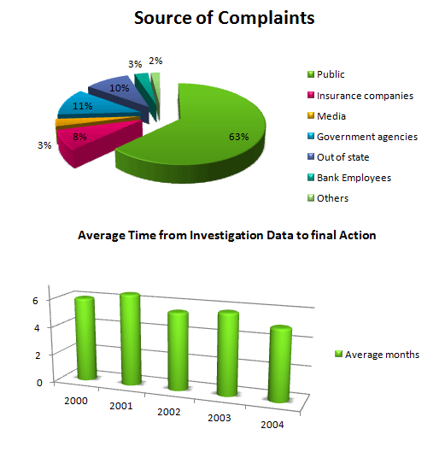

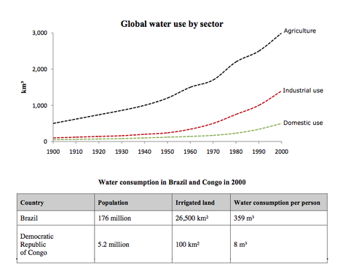

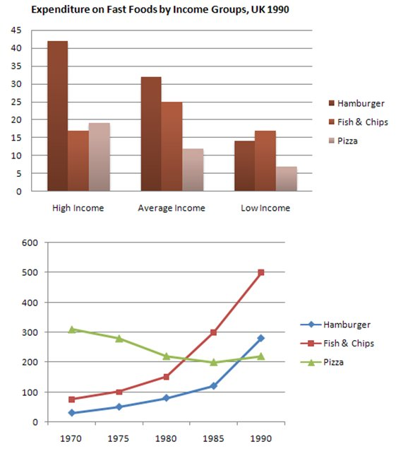

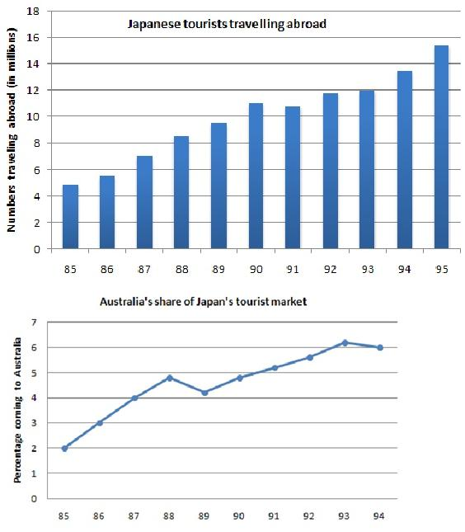

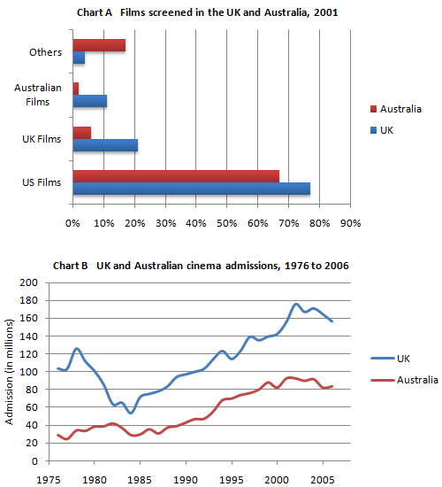

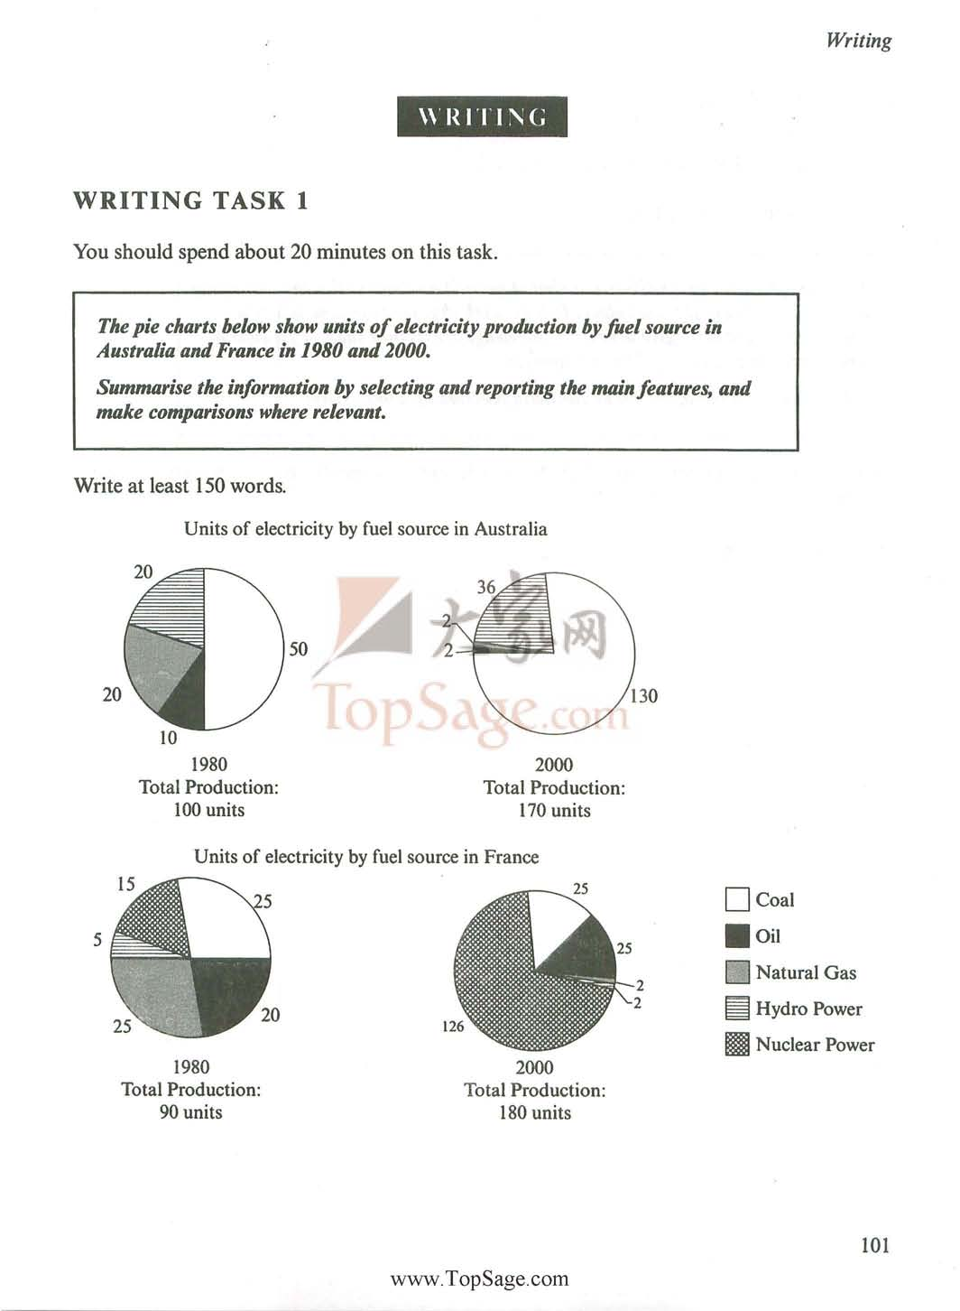

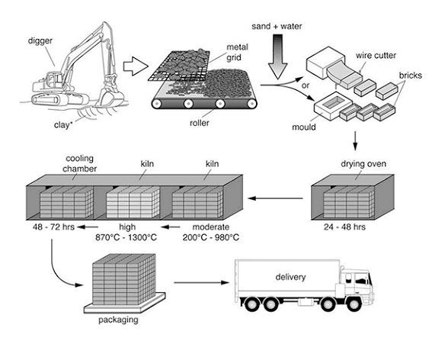

***The diagrams below show some principles of house design for cool and for warm climates.***

[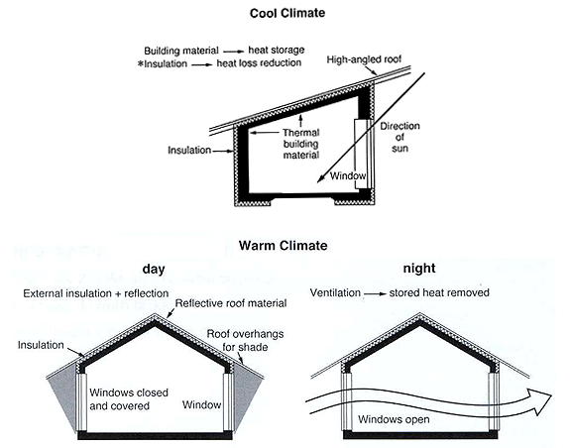](http://ielts-simon.com/.a/6a0120a5bb05d8970c0154328abc3e970c-pi)

***The diagram below shows the water cycle, which is the continuous movement of water on, above and below the surface of the Earth.***

[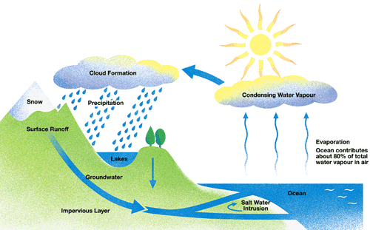](http://ielts-simon.com/.a/6a0120a5bb05d8970c014e60c42739970c-pi)

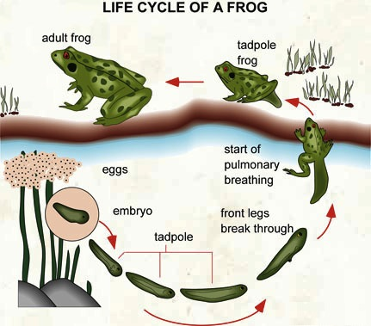

[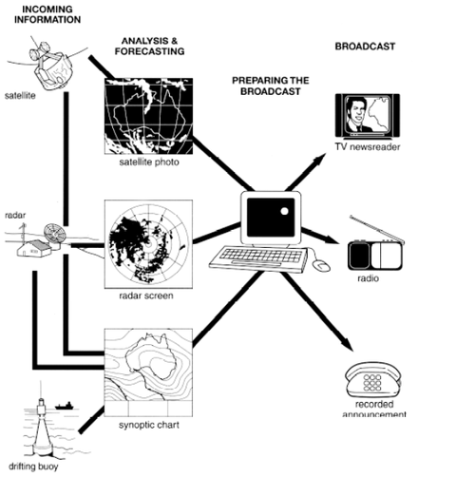](http://ielts-simon.com/.a/6a0120a5bb05d8970c0133f432ca94970b-pi)

### IELTS Writing Task 1: describe a map

***The map below is of the town of Garlsdon. A new supermarket (S) is planned for the town. The map shows two possible sites for the supermarket.***

[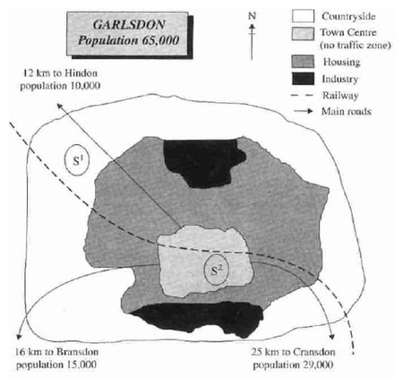](http://ielts-simon.com/.a/6a0120a5bb05d8970c01347fbc3651970c-pi)

(From Cambridge IELTS 5)

*You should spend about 20 minutes on this task. The diagram below shows how a central heating system in a house works. Summarise the information by selecting and reporting the main features, and make comparisons where relevant. You should write at least 150 words.*

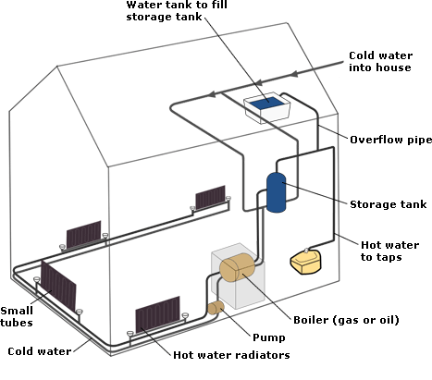

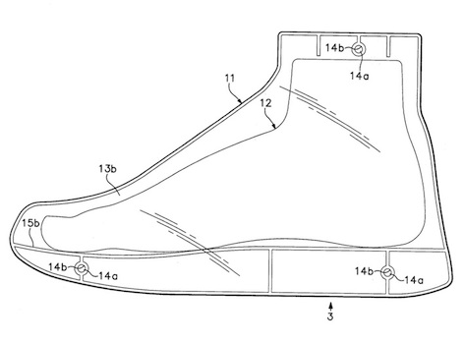***Component Code Reference Chart***

|  |  |
| --- | --- |
| **Component Code** | **Description** |
| 3 | pliable rubber shoe sole |
| 11 | patented one-directional mesh that lets moisture escape but does not let it enter |
| 12 | foot |
| 13b | heat-responsive foam that moulds the shoe to the shape of the foot |
| 14a | air duct allowing air to escape to make the shoe more flexible |
| 14b | flexible rubber framing the air ducts |
| 15b | patented Foamtech foam/plastic mix allowing for greater jumping ability |

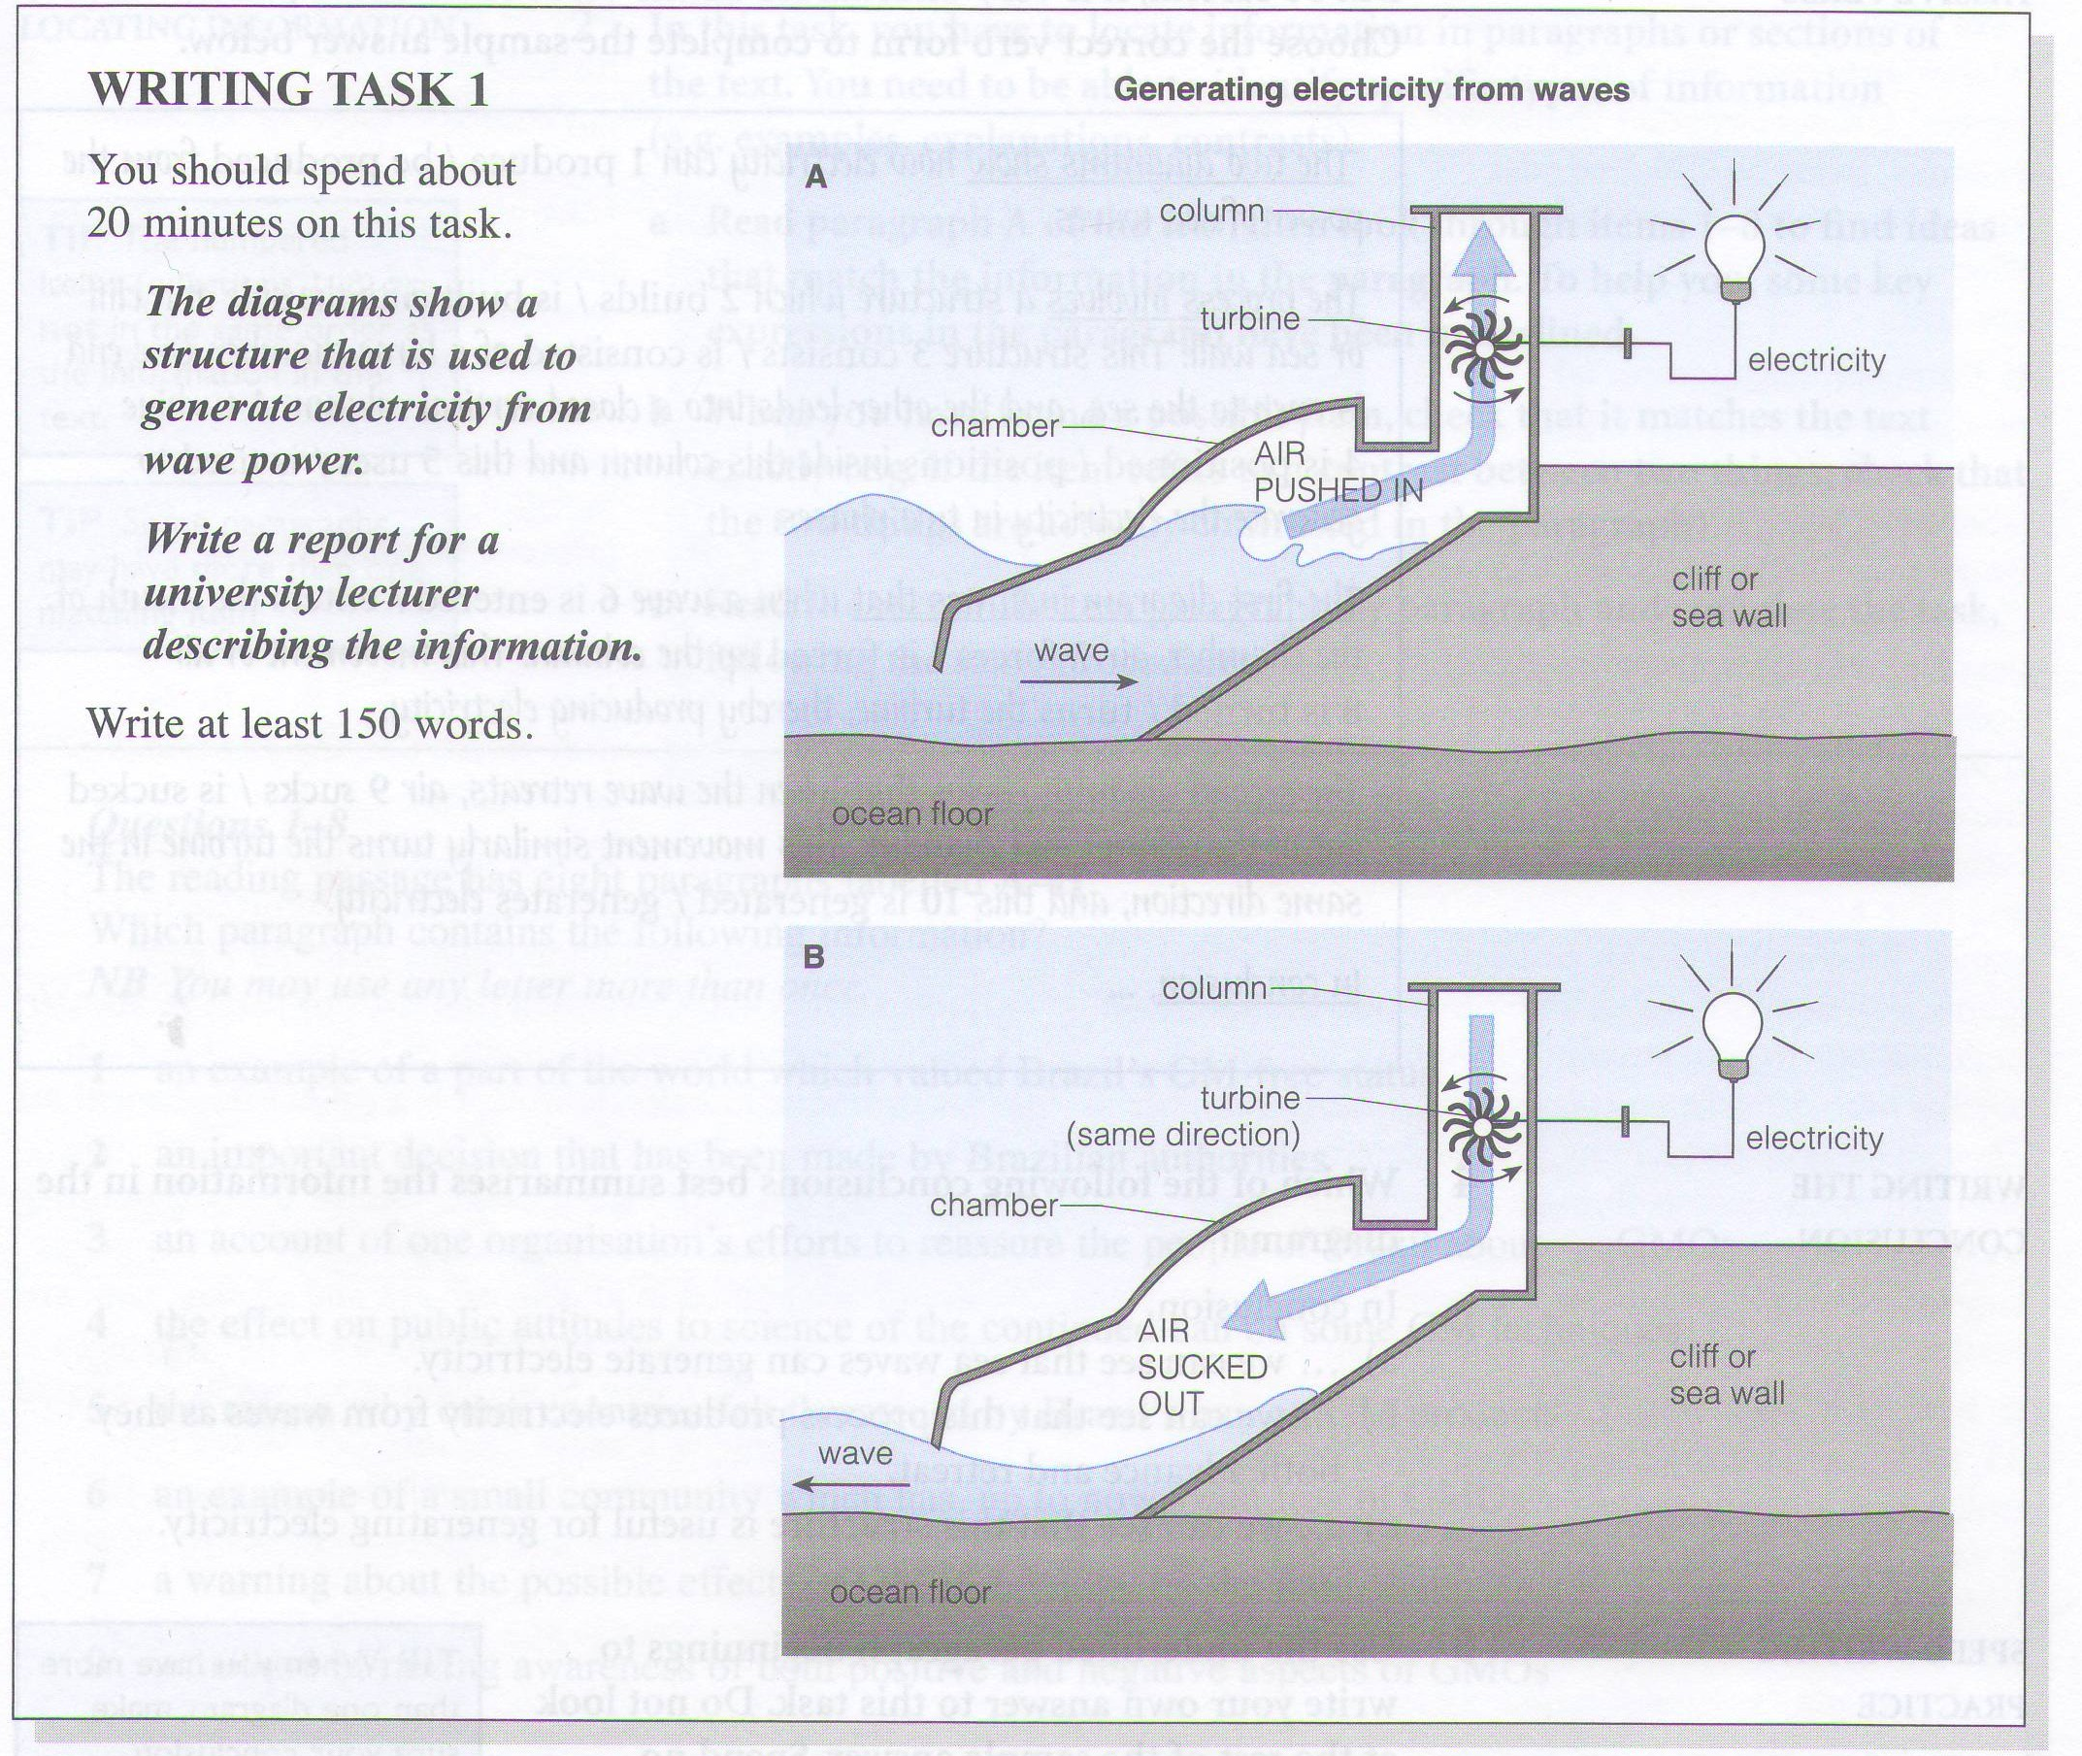

You should spend about 20 minutes on this task.

**The diagram below gives the information about the Hawaiian island chain in the centre of the Pacific Ocean.  
  
Write a report for a university lecturer describing the information shown.**

You should write at least 150 words.

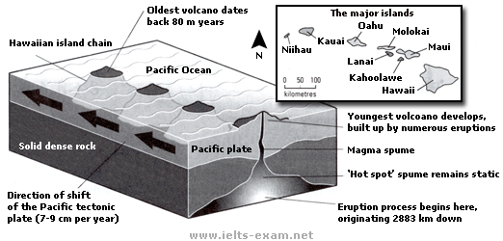

**Sample task**

You should spend about 20 minutes on this task.

**The flow chart below shows how national examination papers are marked in Someland.  
  
Write a report for a university lecturer describing the information below.**

Write at least 150 words.

